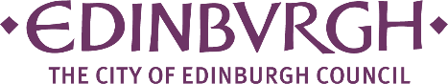
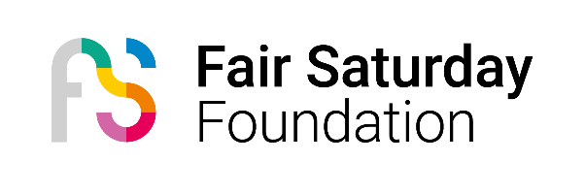

Fair Saturday 2024 Community Event Fund – Supported by City of Edinburgh Council

Fair Saturday Edinburgh
Fair Saturday Edinburgh is Edinburgh’s contribution to Fair Saturday, a global movement with a positive impact that takes place the day after Black Friday and aims to generate a massive mobilisation of people in favour of arts and culture, to highlight their essential role in the construction of a better future. We support the cultural world and the work of social projects. Now more than ever, culture and values are key to building a better future.
Since its inception in 2014, Fair Saturday has presented +3,000 events in +150 cities, involving +42,000 artists, and attracting +770,000 attendees. We welcome participants from all creative fields, amateur and professional, from public or private organisations. Past events have included music, theatre, dance, performance, street art, visual arts, photography, literature, poetry, cinema, circus.
We want to ensure that Fair Saturday Edinburgh is as open and inclusive as possible, and we want artists, communities, and community organisations from all over the city to be involved. Any cultural event planned for 30th November can be part of the Fair Saturday Movement, as long as it ties in with Fair Saturday’s ethos of culture for positive change and support of social projects.
All events will be published together in the Fair Saturday Scotland programme and website, and we will promote all events across our channels and social media.
Inclusivity is at the very heart of Fair Saturday, and it is our goal that people in every community in Edinburgh can take part, as participants and audience.
The Fair Saturday Edinburgh Community Event Fund
This fund has generously been made available by The City of Edinburgh Council and administered by the Fair Saturday Foundation. It is designed to assist community organisations in holding events for their community as part of the Fair Saturday Movement in Edinburgh.
A total budget of £4,500 is available to offer grant awards of up to £500 for events taking place on Saturday 30th November as part of the Fair Saturday Edinburgh Movement. Applicants should apply for the exact amount needed for their event and will not automatically be awarded the full amount of their application submission.
The deadline for applications is midnight on Sunday 6th October. Applicants will be notified of the outcome of their application by Friday 11th October.
Who can apply?
- Artists/creative practitioners, arts-based community hubs and cultural organisations based in Edinburgh.
- Events must comprise cultural activity of some kind, be open to the public, and support either the local community or a social project or charity/CIC/social enterprise. All events must take place in Edinburgh.
- We will prioritise events that are diverse and inclusive, especially those which offer cultural experiences to those who may not have regular access to this.
Applying organisations must have articles of association and a UK bank account under their name. They do not need to be incorporated or registered with OSCR or Companies House.
We will be assessing the likely impact of the event and to what degree it will extend the reach of cultural activity in the city, especially in hard-to-reach communities, greater visibility and representation of community-based practising artists and culture in particular.
Application process
Applications must be submitted using the application form, returned by the stated deadline, and signed by the applicant.
Please contact Suzy Ensom on 07704 449126 or email scotland@fairsaturday.org if you require advice on your application.
If you are successful in your application, we will ask for bank details to make payment transfer. We are enormously grateful to EPAD for assisting us with the payment process.
Successful applicants will be notified by Friday 11th October.

APPLICATION FORM – CONTACT DETAILS
Name of Organisation or artist

Contact Address and Postcode

Contact Name and Position

Phone Number

Contact Email

Organisation or artist website address

Overview of Organisation or artist (including main aims and objectives) - Maximum of 350 words

Charity/Organisation Registration Number (if applicable)

APPLICATION FORM – EVENT DETAILS
Event Title (as it will appear in any publicity):

Event date and time:

Event location (including postcode):

Any partners involved:

Please describe the event you are seeking funding for. (max 250 words)

Who will benefit from your event? Please include direct and indirect beneficiaries (eg: partners, community, participants) (max 200 words). How many people do you expect will attend/benefit?

EVENT BUDGET
How much do you wish to apply for?

Please provide a breakdown of what this will be spent on:
Item: | Cost:

Will this funding cover the total cost of the event?
Yes/no
If no, please include any additional costs (over and above the grant) here:
Item: | Cost:

Please let us know where you expect the additional funding required to come from e.g. other funding sources, sponsorship, ticket sales etc.

DECLARATION
Please be aware that on completion of this application form you are also authorising Fair Saturday Foundation to retain all data submitted within it for its use.
Policies and Procedures: If your event involves working with children or vulnerable adults at risk, you must have relevant policies and procedures in place to prevent abuse and respond to actual or suspected abuse, neglect, or exploitation. Please delete as appropriate.

Child Protection policy and procedure: yes/no/not applicable
Adult Protection policy and procedure: yes/no/not applicable

You are being asked to declare that to the best of your knowledge the information contained in this application is accurate.
Name:
Date:
Type Signature:

